1/3 INCH COLOR CAMERA

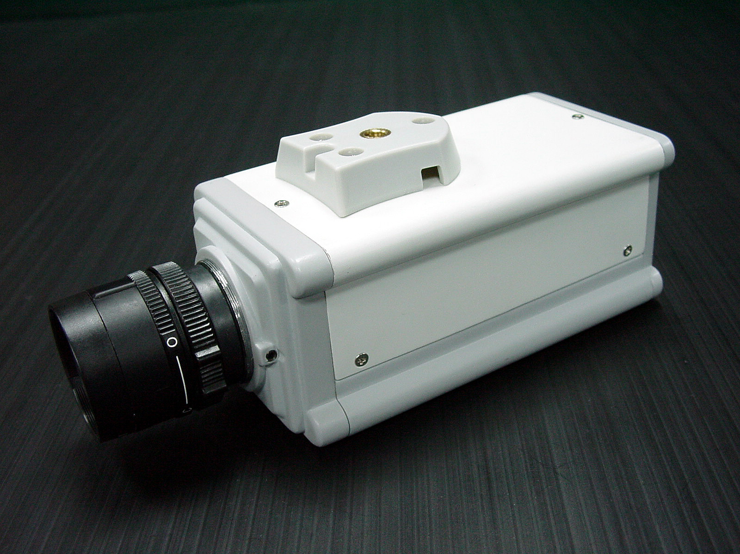

S P E C I F I C A T I O N S

1/3 INCH COLOR CAMERA

MODEL NO.: C3803-01B1 (NTSC) / C3804-01B1 (PAL) (DC12V)
C3803-01B2 (NTSC) / C3804-01B2 (PAL) (AC24V)
C3803-01B3 (NTSC) (AC110V) / C3804-01B4 (PAL) (AC230V)
C3803-01B5 (NTSC) / C3804-01B5 (PAL) (DUAL)

PICK UP DEVICE: 1/3 INCH SONY CCD SENSOR
IMAGE SIZE: 3.64 (H) x 4.82 (V) mm
PICTURE ELEMENTS: 510 x 492 (NTSC) 500 x 582(PAL)
WHITE BALANCE: AUTO
BACK LIGHT COMPENSATION: ON / OFF
GAIN CONTROL: AUTO
ELECTRONIC SHUTTER: NTSC: 1/60s to 1/100,000s, PAL: 1/50s to 1/110,000s ON/OFF
SWITCHABLE
AUTO IRIS LENS CONTROL: VIDEO OR DC DRIVE SWITCHABLE
POWER SOURCE: DC12V, AC 24V, 110V, 230V ±10%
OPTION: DUAL VOLT DC12/AC24V ±10%
POWER CONSUMPTION: DC: 250mA (MAX.), AC: 3.2W (MAX.)
HORIZONTAL RESOLUTION: 420 TV LINES
SIGNAL NOISE RATIO: MORE THAN 48dB
VIDEO OUTPUT: 1 Vp-p COMPOSITE VIDEO OUTPUT, 75 OHMS
MINIMUM ILLUMINATION: 0.02 LUX, F=1.2
GAMMA CORRECTION: 0.45
SYNC. SYSTEM: INTERNAL
LENS MOUNT: C & CS MOUNT
OPERATING TEMPERATURE: -10°C to +50°C
DIMENSIONS (WxHxD): 54x50x120mm
WEIGHT: 560g

